ChINESE FLAGSHIP SECONDARY CURRICULUM
Chinese II, Unit 4, Home and Community
Interpretive Reading Assessments
Learning targets:
1. Students can read a simple map to get somewhere.
2. Students can read the information about a house.
3. Students can interpret a real estate advertisement.

Interpretive Reading Assessment 1
Scenario: You just arrived at the airport in Shanghai, China for a tour with your friend. You would like to get to the hotel you booked before you came to China. You grab a tour/city map from the information desk. Please read the following map and point out the directions and transportation to your friend that you need in order to get to the hotel.
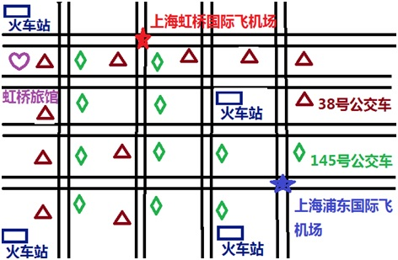

In your map reading, you should include the following locations:
· The hotel;
· The bus stops;
· The train station.

Interpretive Reading Assessment 2
Scenario: You are an exchange student in Shanghai International Middle School for a year. Your friends from U.S. just got to Shanghai, China and would like to rent an apartment. With their limited Chinese, they ask your help. They’d like to have three bedrooms, one living room, one dining room, one kitchen, and one restroom. Please read the following apartment rental advertisements and circle the best for your friends.
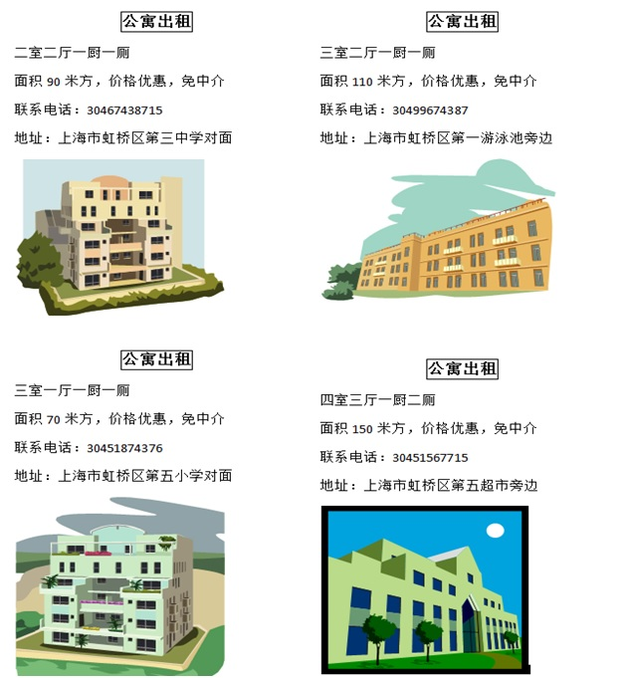
Adapted from Jefferson County Public Schools, KY, 2011

